Document Customizer - Customs Tariff*
Phase | Description | Navigation
Dependency on Shipping Manager | This requires that the Shipping Manager is installed.  Make sure that Customs Tariff feature is activated in BC.  - Search for Shipping Manager Setup  - Click on Detailed App Setup  - Enable Show Customs Tariff | 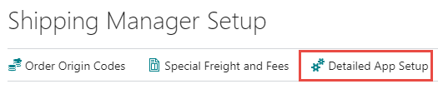
Add standard setup | When the Show Customs Tariff is enabled in Detailed App Setup it is possible to install the standard setup in Document Customizer.  - Search for Document Customizer  - Click on Action -> Add setup for new document types -> Customs Tariff Setup | 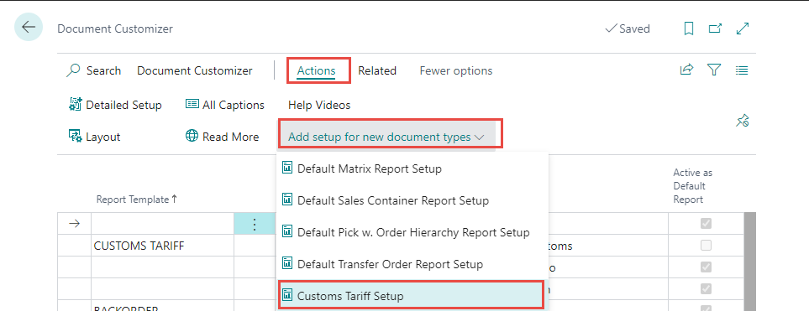
Setup for Customs columns | A new setup area for Custom Tariff columns has been added to the Document Customizer. Making it possible to edit the information in the section.  It works the same way as columns. | 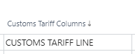  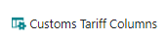
Print out on Document | If values are in the table on the document and a template is chosen, the section will be shown after section 1 and before VAT specification on the document**.  ** Sales order confirmation, Proforma Invoice, Posted Sales Shipment, Posted Sales Invoice. | 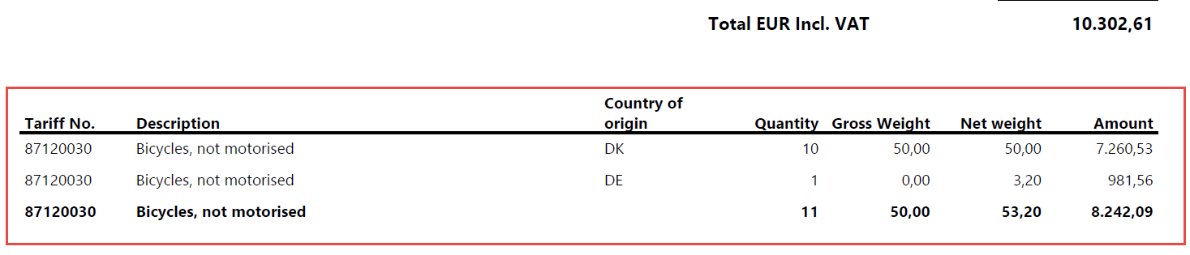
* Possible from version 19.

