Document Customizer - Specify font for Barcodes
Here is described how to set the font and size, used for Barcodes on document lines.
Phase | Description | Navigation
Open Document Customizer Layouts | Go to Document Customizer and open Layout | 
Open Card view | Open the layout setup in card view, click on edit. | 
Specify Barcode in 1D or 2D | In Phane Barcode, chose in Barcode type, if the barcode should be in 1D or 2D | 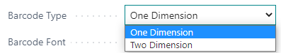
Specify Barcode Font | Select from the list which barcode font should be used
Specify Font Size | In- or decrease the number in Barcode font size, depending on the barcode size desired.

Hints!

My barcode does not fit in the column width
Then you can either make the column width wider or make the barcode font size smaller.

