Rental Management: Suspend, Return, Replace

Suspend Rental Item
When running rental invoicing through an Invoicing Plan, you will have the ability to suspend specific quantities of delivered Rental Items meaning that these quantities will no longer be invoiced. The purpose of the feature is to be able to stop the invoicing of a rented item even though the item has not yet been physically returned.
It could e.g. be that a part is failing and agreement is made with the customer to return it as soon as possible, but at the point of time the agreement is made, we do not have details about when it will arrive or which specific Serial Number it is.
In that case we can adress the issue by suspending 1 piece of this item on the rental order.
Example: We have shipped 5 items to the customer, the base price is 4990:
In the invoicing plan, the unit price calendar will show one line:
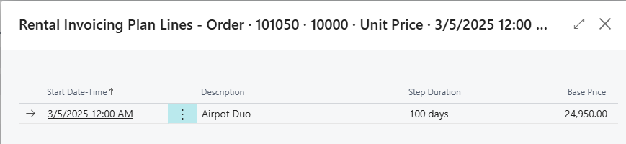
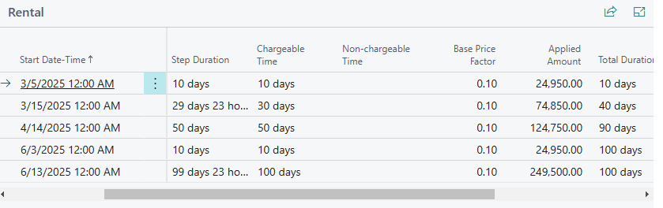
Imagine that after a month the customer informs us that one of these items has failed. In that case, we can activate Suspend Item on Rental Line:
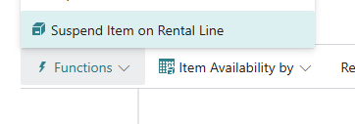

The system will open the Rental Suspensio Entries page. The caption will contain information about the item and the quantity available for supension.
Fill in Item Quantity and state the date from when the suspension should come into effect:
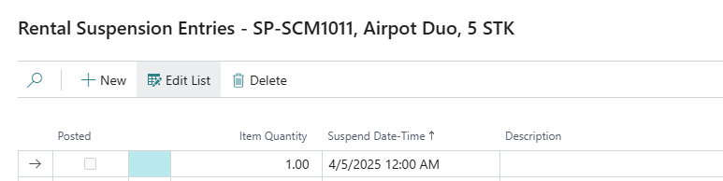
After closing the page, you’ll see that the suspension fields have been filled in on the line:
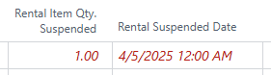
The suspensions affect the invoicing amount through the Invoicing Plan. The rental invoicing plan will reflect the suspension, both in the Unit Price calendar but also in the overall plan and the total invoice amount.
In the unit price calendar we can see how a calendar entry has been cut short by the suspension.
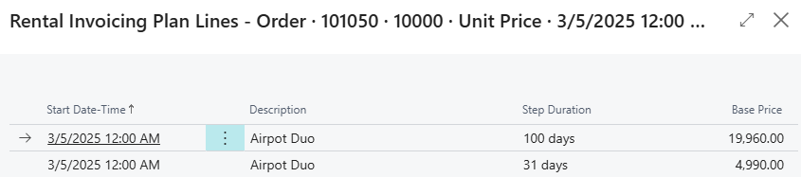
And in the Invoicing Plan we see how the invoiced amounts are lower after the suspension date.
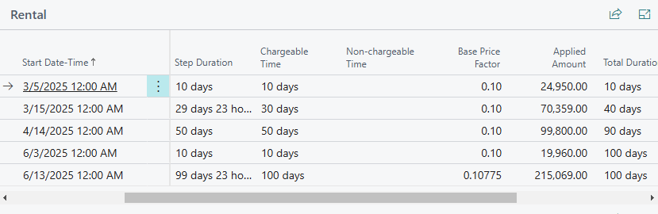

The suspension entries can be changed and deleted as long as the changes do not affect an invoiced period.
Suspensions will be paired with items that are subsequently returned.
If suspensions have been defined on a line that is later split due to partial return, the suspensions will remain on the original line to the extend the returned quantity covers the suspended quantity. If it does not, the remainder suspension quantity will be moved to the non-returned line.
This principle ensures that the Invoicing Plan is not affected by the return of suspended items.

Return/Replace Rental Item
It is possible, directly from the Rental Sales Order, to initiate the return of items that have been transfer posted to the rental location.
Furthermore, it is possible to combine the return of an item with an immediate item replacement hereby ensuring that the rental can run without interruption.
The functions are accessed via the Sales Order Line functions menu.
To return items, you activate Partial Return of item(s) on Rental Line:
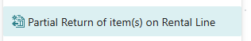
To return and replace items, you activate Replace Item on Rental Line:
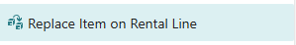
Below we describe the workflow of the Replacement process, but the user process of selecting the item(s) to return is completely similar.

How to do Return/Replace
Activate the Return/Replace function from the Sales Order Line functions menu.
This will open up the Replace Rental Item (Return Rental Item) page:
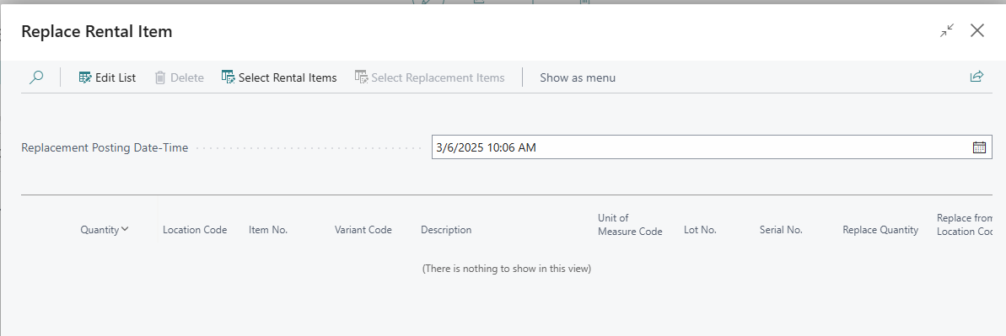
This is the interface that we’ll use to enter the needed information to execute the replacement (either fully or partially as explained above).
- We’ll need to enter a posting date that will be used for the return/replacement posting (in the first of the below principles - Automatic Transfer Posting - it will be used as the posting date). This is the Return/Replacement Posting Date-Time field. By default, the system will suggest the current date and time.
- We’ll select the item(s) to return by clicking the Select Rental Items button. This will open up a list of rental items from the current Sales Line that currently reside at the rental location. You select which item(s) to return by filling in the Selected Quantity column.
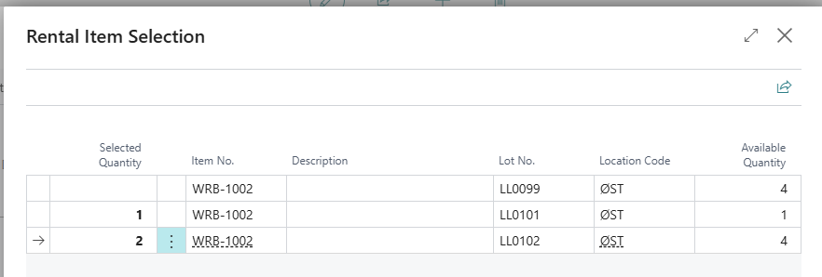
- After selecting the item(s) to return, the system will make suggestions regarding the replacement. These suggestions are:
  - Replace the entire quantity that was originally rented out on the rental sales line.
  - Replace with the same type of item (and variant, if the original rental sales line was for an item variant).
  - Replace from the same location that was originally used on the rental sales line.
If any of these suggestions need to be modified, this can be done by clicking the Edit List button and change these values.
- If we are preparing replacement we will, as the concluding step, select the replacement item(s). By clicking the Select Replacement Items button we’ll get a list of the available items. The list will be a summation based on Item Tracking. You select the specific items by filling in the Selected Quantity column. When this is done, press OK to update the current replacement line with the selection.
- When the preparation of data is completed, you can either execute the return/replacement by pressing OK on the Return/Replace Rental Item page or you can press Cancel to abort.

How Return/Replace is executed
Depending on the setup, the system will execute the Item Return and Replacement using one of two principles :
- Automatic Transfer Posting
- Manual Transfer Posting
Automatic Transfer Posting is invoked when the locations involved do not require warehouse handling and the Rental Setup field No Transfer Posting in Return/Replacement is unchecked.
Manual Transfer Posting is invoked when one or more of the involved locations require warehouse handling (in this case the Rental Setup field Allow Partial Termination Without Return must be checked) or the Rental Setup field No Transfer Posting in Return/Replacement is checked.

Description of Automatic Transfer Posting
The locations involved do not require warehouse handling and the item(s) to return will be transfer posted from the rental location to the home location.
If a quantity less than the original quantity on the rental sales line is to be replaced, the remaining quantity will be split onto a new rental sales line to remain at the rental location for continuing rental.
If replacement has been defined, new rental sales line(s) on the sales order will be created for the replacement item(s) and these will be transfer posted to the rental location.

Description of Manual Transfer Posting
The rental sales line for the item(s) to return will be updated with a Rental Return Date reflecting the end of the rental period in which the replacement is planned to take place. The Lock Rental Return Date will be ticked to secure that potential invoicing won’t prolong the rental period.
Shipment Date and Receipt Date on the inbound transfer line will be updated based on the Rental Replacement Date-Time which also will be written on the line.
The associated rental relation line will be marked as Pending Return.
If a quantity less than the original quantity on the rental sales line is to be replaced, the remaining quantity will be split onto a new rental sales line to remain at the rental location for continuing rental.
If replacement has been defined, new rental sales line(s) on the sales order will be created for the replacement item(s) and related outbound transfer line(s) will be created with Shipment Date and Receipt Date filled in, in direct extension of the Rental Return Date of the item(s) to return.

