Special Order Flow:

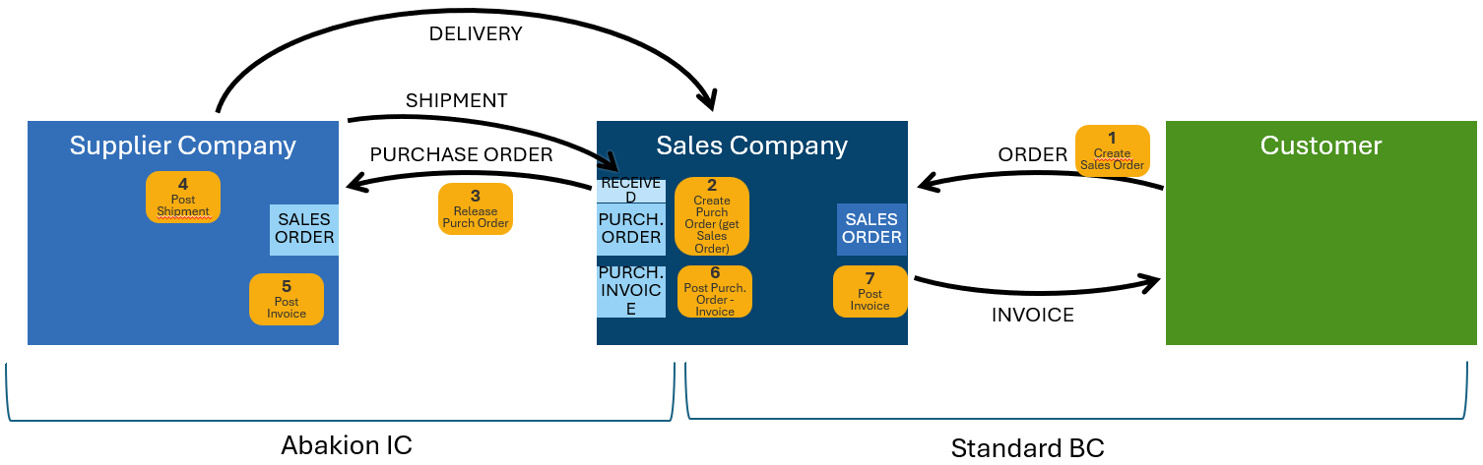

1. End customer places an order the SALES company. Sales Order is manually created in the SALES company. Make sure that the purchasing code on the sales lines is set to SPECIAL and the field Special Order = true
2. Next step is to create a Purchase Order for the Intercompany Vendor (INVENTORY company). Follow standard BC procedure for linking the Purchase Order with the Sales Order. (Get Sales Order – either from the Purchase Order or from Requisition Worksheet – on the Requisition Worksheet, make sure that the IC Vendor is put in the Vendor No. field).
3. Release the Purchase Order. Intercompany process will start and automatically create the Sales Order in the INVENTORY company.
4. Post the Shipment of the Sales Order in the INVENTORY company. Receipt for the Purchase Order will automatically be posted in the SALES company. The Items will be delivered and get on stock in the SALES company.
5. Post the Invoice of the Sales Order in the INVENTORY company.
6. Post the Invoice of the Purchase Order in the SALES company.
7. Post the Invoice of the Sales Order in the SALES company.